This file represents the adaptation of the Store_Sales schema to a Star Schema

TPC-DS Original

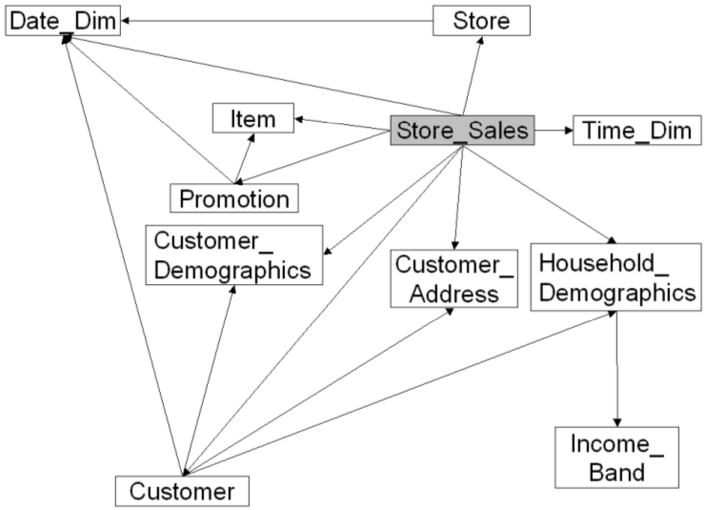
TPC-DS Alterated
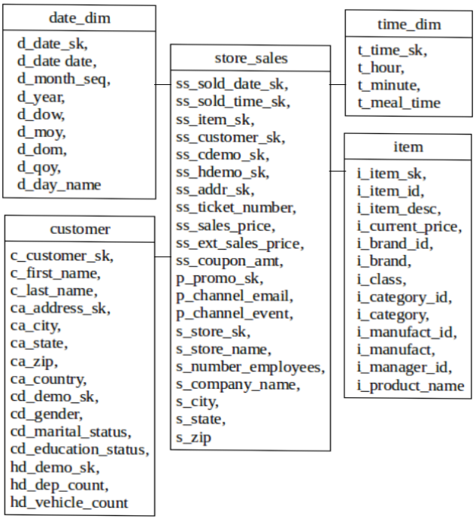
Comparing the schemas it's possible to notice that the tables Customer_Demographics, Customer Address, Household_Demographics and Customer was joined into a single Customer table and the tables Store, Promotion and Store_Sales was joined into a single Store_Sales table.

